**MCSE 1 Windows client operating systems Lecture 1**

**Versions of Windows client and server operating systems**

|  |  |  |
| --- | --- | --- |
| **Client operating system** | **Server operating system** | **Client Update support**  **Offered by Microsoft** |
| Windows NT workstation | Windows NT4 | No longer supported |
| Windows 2000 Pro | Server 2000 | No longer supported |
| XP | Server 2003 | No longer supported |
| Vista | Server 2008 | No longer supported |
| Windows 7 | Server 2008 R2 | Currently no deadline |
| Windows 8 | Server 2012 | Currently no deadline |
| Windows 8.1 | Server 2012 R2 | Currently no deadline |
| Windows 10 | Server 2016 | Server 2016 is not available until some time in 2016 |

This course deals with Microsoft’s Windows 7, Windows 8 and Windows 10 operating systems. Windows 10 was released on July 29, 2015. It is a free upgrade for users who have a legitimate copy of Windows 7 or Windows 8.1.

XP and Server 2003 are fairly stable operating systems and there is still a large number of networks using them. A lot of organizations using XP and Server 2003 could not justify the cost of upgrading to Windows 7/8/10 and Server 2008/2012. There had to be a significant benefit to justify the cost and training that has to go into maintaining a network running on the newer operating systems. For instance, if a company has 100 XP client machines and four 2003 servers, the upgrade to the latest client server operating systems would cost:

Windows 10 Pro client license = $199 x 100 machines = $19,900

Server 2012 R2 with 10 CALs = $750 x 4 servers = $ 3,000

(prices - circa: Sept 2015) Total = $22,900

On top of this, you must purchase enough CALs (Client Access License) to cover the number of users concurrently accessing your servers. Finding the cost of the CALs is a very involved process. You can’t just say “how much are 100 CALs, please”, and get a quote.

**CAL** (Client Access License)

In a client server network, the clients and the servers require a licensed copy of the operating system as mentioned above. To remain legal, the organization must then purchase CALs to allow the clients to access the servers. There are a number of different CAL types; per server, per client, per processor, etc. Understanding how CALs are purchased is not part of this course.

**System Requirements for an installation of Windows 7**

There are 6 versions of Windows 7:

1. **Windows 7 Starter**

Low cost, watered-down version of Windows 7 used in netbooks and low end laptops. “Starter” only comes in a 32-bit version, only some Aero features, and limited processor support.

**This operating system cannot be joined to a domain.**

2. **Windows 7 Home Basic**

No Windows Media Center, lacks most Aero support, and has limited networking capabilities. Restricted to use by emerging markets such as aid-programs in third-world countries. Established markets will not have access to this version.

**This operating system cannot be joined to a domain.**

3. **Windows 7 Home Premium**

Intended for retail and OEM version markets. Lacks business features such as the ability to participate in client/server networks.

**This operating system cannot be joined to a domain.**

4. **Windows 7 Professional**

Intended for the retail market where users are more advanced or for the medium-sized business market. “Professional” does not contain BranchCache and DirectAccess. **This operating system can be joined to a domain.**

5. **Windows 7 Enterprise**

Full blown Windows 7. Identical features found in Windows 7 Ultimate. The only difference between this version and Ultimate is this version gets its registration key from a Microsoft server.

**This operating system can be joined to a domain.**

6. **Windows 7 Ultimate**

Full blown Windows 7, same as the Enterprise version. The only difference between this version and Enterprise is this version is intended for single user environments where the registration key comes with the software.

**This operating system can be joined to a domain.**

**We are using the Windows 7 Enterprise version in this course.**

**Hardware Requirements for Windows 7**

32-bit (x86) requires a 1 GHz processor, 1 GB of RAM, and 16 GB of HDD

64-bit (x64) requires a 1 GHz processor, 2 GB of RAM, and 20 GB of HDD

**Hardware limitations for Windows 7**

|  |  |  |  |  |  |  |
| --- | --- | --- | --- | --- | --- | --- |
|  | Starter | Home  Basic | Home  Premium | Professional | Enterprise | Ultimate |
| Architect | 32 | 32/64 | 32/64 | 32/64 | 32/64 | 32/64 |
| RAM-32 | 2GB | 4GB | 4GB | 4GB | 4GB | 4GB |
| RAM-64 | N/A | 8GB | 16GB | 192GB | 192GB | 192GB |
| 2 processor | No | No | No | Yes | Yes | Yes |
| Peer Nets | 0 | 5 | 10 | 10 | 10 | 10 |

**Versions of Windows 8**

Windows 8 introduced a whole new look to the user interface. The idea was to have one operating system that could be used on laptop/desktop computers as well as hand held devices like tablets and phones. Most people have some form of mobile phone where the user makes selections by finger swiping. This is the market that Microsoft is trying to tap into. Windows 8 can be navigated with a touch screen or keyboard and mouse.

**Windows 8**

Windows 8 is the basic edition of Windows for the 32-bit and 64-bit architectures. This edition contains features aimed at the home [market segment](http://en.wikipedia.org/wiki/Market_segment) and provides all of the basic new Windows 8 features including the Start screen with semantic zoom, live tiles. **Can’t be used in a client/server network so it is not much good for business use.**

**Windows 8 Pro**

Windows 8 Pro is comparable to Windows 7 Professional and Ultimate and is targeted towards enthusiasts and business users; it includes all the features of Windows 8. Additional features include the ability to receive [Remote Desktop](http://en.wikipedia.org/wiki/Remote_Desktop_Services) connections, the ability to participate in a [Windows Server domain](http://en.wikipedia.org/wiki/Windows_Server_domain), [Encrypting File System](http://en.wikipedia.org/wiki/Encrypting_File_System), [Hyper-V](http://en.wikipedia.org/wiki/Hyper-V), [Group Policy](http://en.wikipedia.org/wiki/Group_Policy) as well as [BitLocker](http://en.wikipedia.org/wiki/BitLocker_Drive_Encryption) and BitLocker To Go. **Designed for client/server networks.**

**Windows 8 Enterprise**

Windows 8 Enterprise provides all the features in Windows 8 Pro with additional features to assist with the IT organization.

**Designed for client/server networks.**

[**Windows RT**](http://en.wikipedia.org/wiki/Windows_RT) **(watered-down Windows 8)**

Windows RT will only be available pre-installed on [ARM](http://en.wikipedia.org/wiki/ARM_architecture)-based devices such as tablets. It includes touch-optimized desktop versions of the basic set of Office 2013 applications—[Microsoft Word](http://en.wikipedia.org/wiki/Microsoft_Word), [Excel](http://en.wikipedia.org/wiki/Microsoft_Excel), [PowerPoint](http://en.wikipedia.org/wiki/Microsoft_PowerPoint), and [OneNote](http://en.wikipedia.org/wiki/Microsoft_OneNote), and support device encryption capabilities. **Several business-focused features such as Group Policy and domain support are not included.**

**Windows 8.1**

Windows 8.1 hit the market on Oct 17, 2013.

Windows 8 was not well accepted by the public and it is generally felt that the slump in sales of new PCs was in part, due to the radically different appearance of Windows 8 which most new PCs came with.

**If you want to run Windows 8.1 on your PC, here's what it takes:**

- Processor: 1 gigahertz (GHz) or faster

- RAM: 1 gigabyte (GB) (32-bit) or 2 GB (64-bit)

- Hard disk space: 16 GB (32-bit) or 20 GB (64-bit)

- Graphics card: Microsoft DirectX 9 graphics device with WDDM driver.

**Windows 10**

Windows 10 was officially released to the public on July 29, 2015.

There are 4 major versions of Windows 10:

**Windows 10 Home**

Intended for use by the general public in a non-business environment. This version cannot be joined to a domain so it cannot participate in a client/server network. It lacks many of the features of the other versions of Windows 10.

**Windows 10 Pro**

Intended for small businesses. It lacks some of the features employed in networks associated with large businesses. This version can join a domain and therefore can be used in a client/server network.

**Windows 10 Enterprise**

This is the full blown version of Windows 10. This version can join a domain and therefore can be used in a client/server network. This is the version used by large corporations.

**Windows 10 Education**

Same as Windows 10 Enterprise. The only major difference is in the licensing of the software. **This is the version we are using in the Lab.**

**If you want to run Windows 10 on your PC, here's what it takes:**

- Processor: 1 gigahertz (GHz) or faster

- RAM: 1 gigabyte (GB) (32-bit) or 2 GB (64-bit)

- Hard disk space: 16 GB (32-bit) or 20 GB (64-bit)

- Graphics card: Microsoft DirectX 9 graphics device with WDDM driver.

(Same hardware requirements as for Windows 8.1)

**Hardware Compatibility List (HCL)**

Ensuring that the hardware requirements are met is only half the battle. You should ensure that the hardware is compatible with the operating system. Microsoft supplies a list of hardware products that have been tested and known to be compatible with each of their operating systems.

If you go to [**www.microsoft.com/whdc/hcl/default.mspx**](http://www.microsoft.com/whdc/hcl/default.mspx)you can check to see if the hardware you plan to use is on the list of compatible hardware products. See figure 1.

Note: if your hardware is not on the list, this does **not** mean you will have problems!

Let’s say you plan to purchase the Linksys **WUSB54GC** wireless NIC and your operating system is Windows 7. Figure 1 shows the results of the HCL.

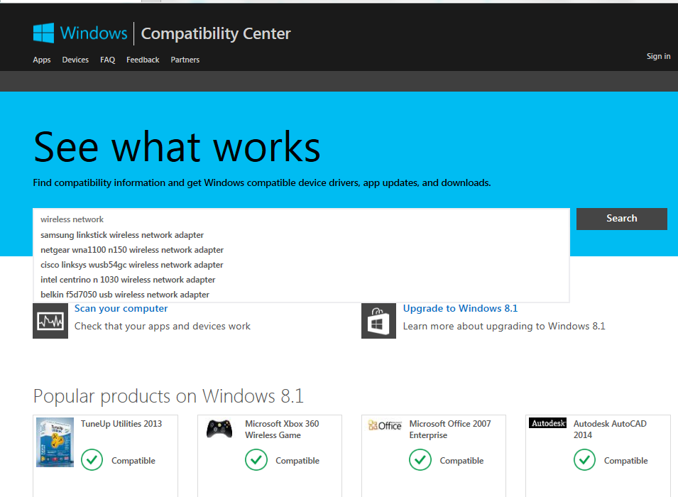

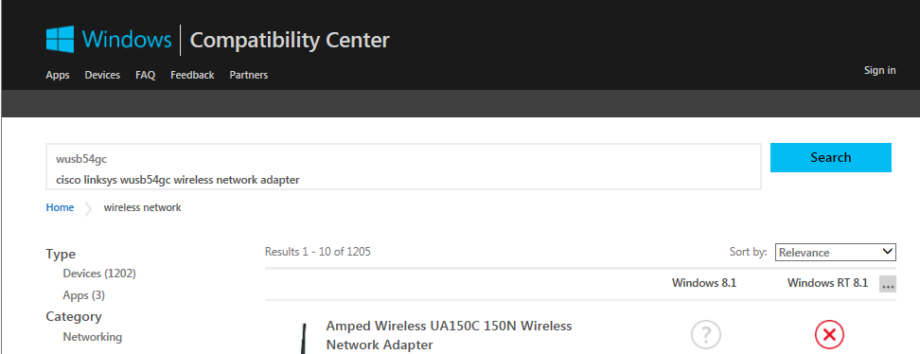

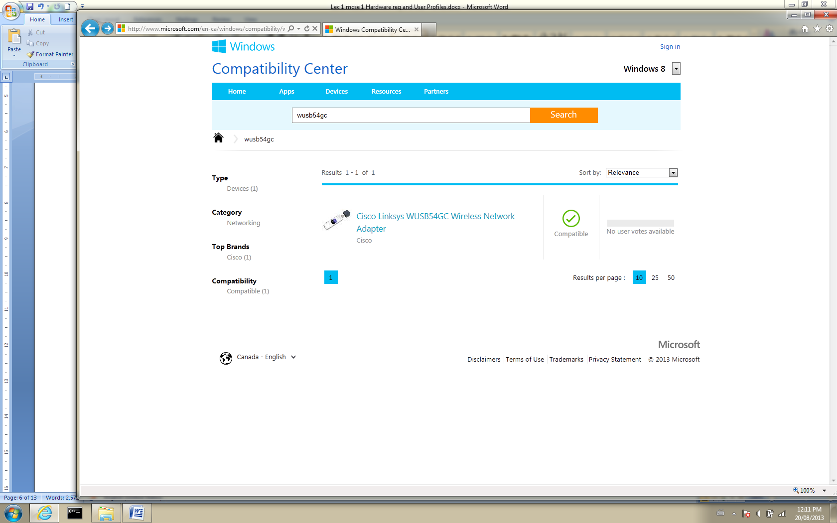

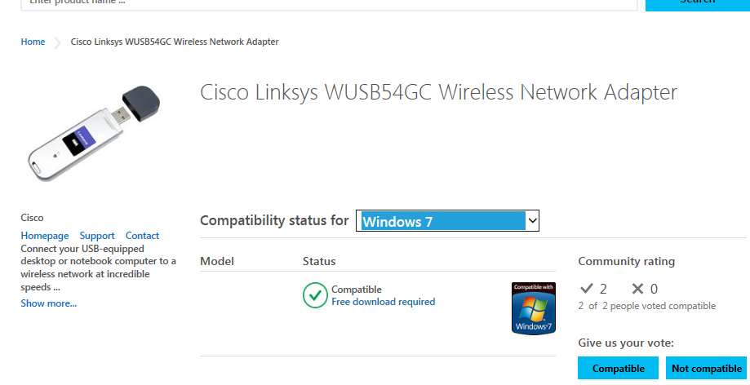

Fig. 1 Microsoft’s HCL web site to check hardware compatibility

**How to check if a computer will support Windows 7 or Windows 8**

You can check to see if your computer is capable of running Windows 7 or Windows 8 by downloading a compatibility-checker program for the operating system in question. Google “**Find out if your PC can run Windows 7**”. Choose the appropriate Microsoft Web site from the list of web sites. Figures 2 and 3 show the web sites you choose to check the compatibility of your computer for Windows 7 and Windows 8.

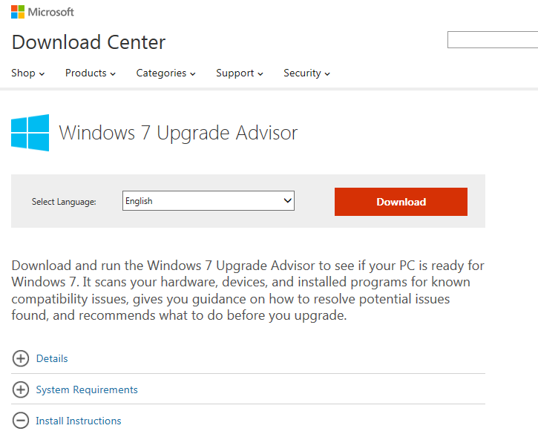

Fig. 2 Web site to check if computer will run Windows 7

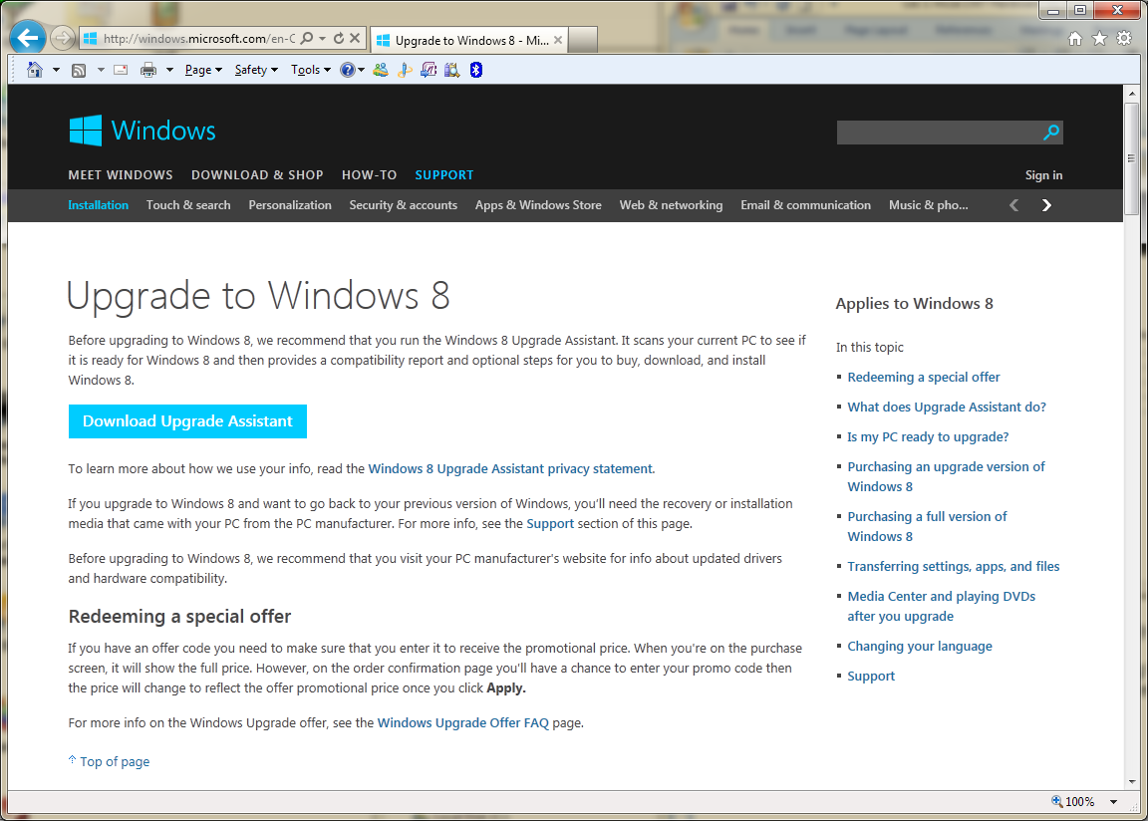

Fig. 3 Web site to check if computer will run Windows 8

**How to check if a computer will support Windows 10**

There is a 3rd party application on the WEB that can be used to check to see if Windows 10 will have any issues installing on your computer. Microsoft has not come out with its own compatibility application yet; (as of Sept 2015).

**Maintaining the client’s environment**

**User Profiles**

Every time you log into a computer you get the same desktop and settings that you had when you logged out of the computer. Any changes you make to your environment are saved in a special area called the user’s profile. Each user has his own local profile which configures the system to look the same each time the user logs in.

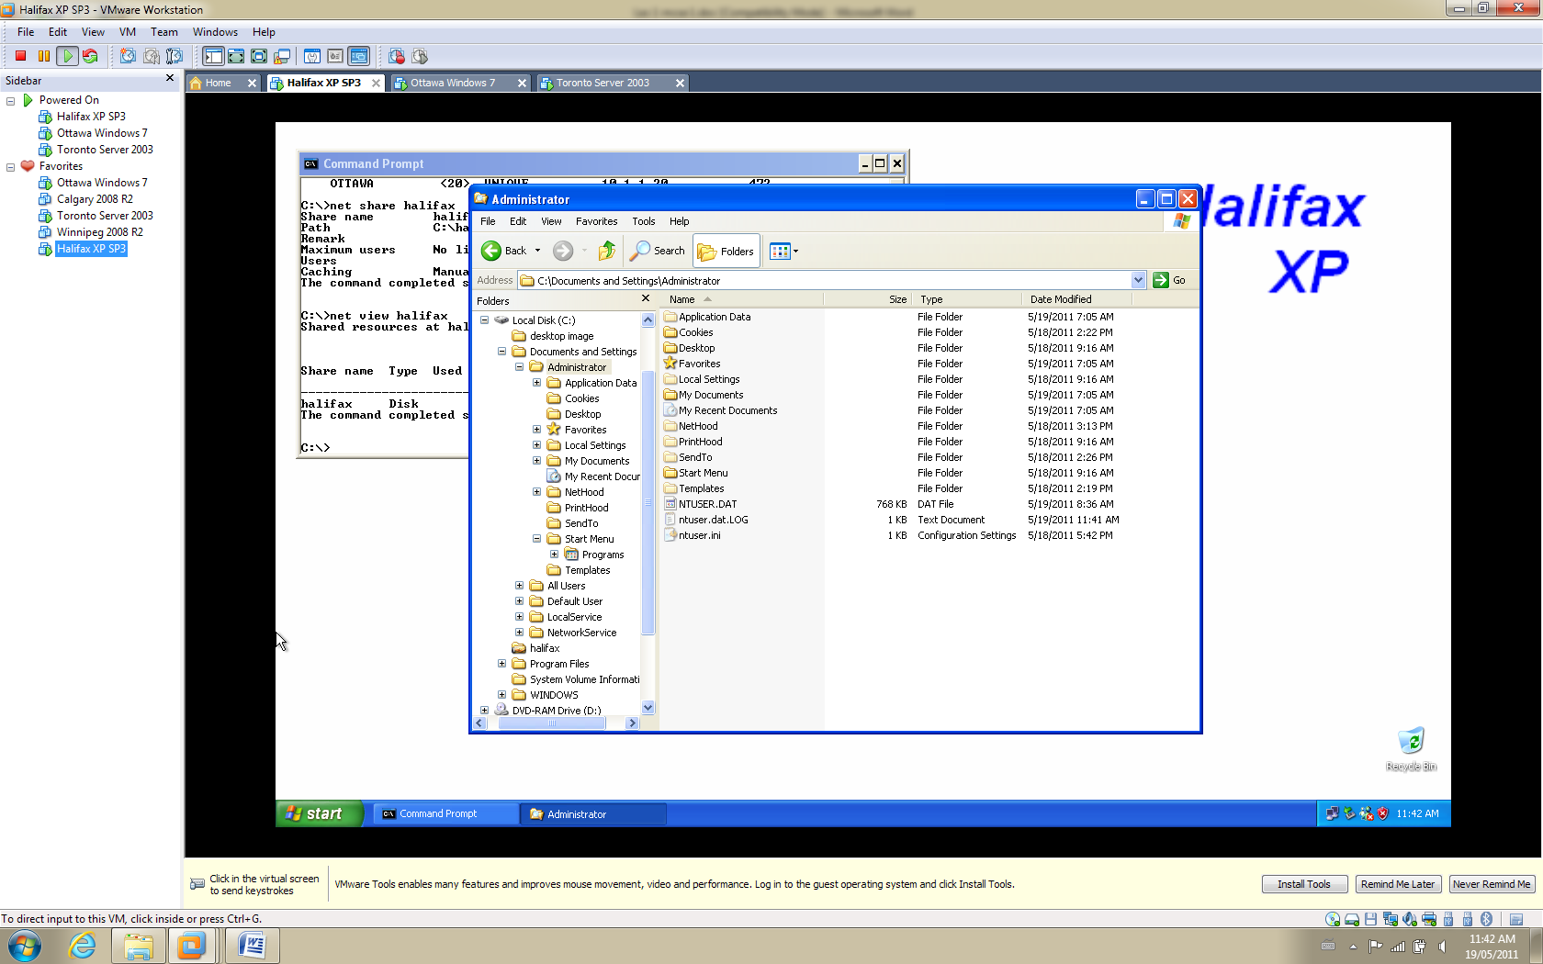When a user first logs in, he has no profile. There is a Default User profile found in the same directory the rest of the user profiles are kept in. When a new user logs in, the Default User profile is copied to the new user’s profile so he has a profile to start with. As time goes on, the user configures his desktop and other settings so his profile becomes unique.

For XP, the profiles are kept in a folder called **Documents and Settings** in the root of C:. The user’s profile shows up as a folder bearing the user’s login name. Figure 4 shows the profile for the Administrator when XP is the operating system.

Fig. 4 User profile in XP

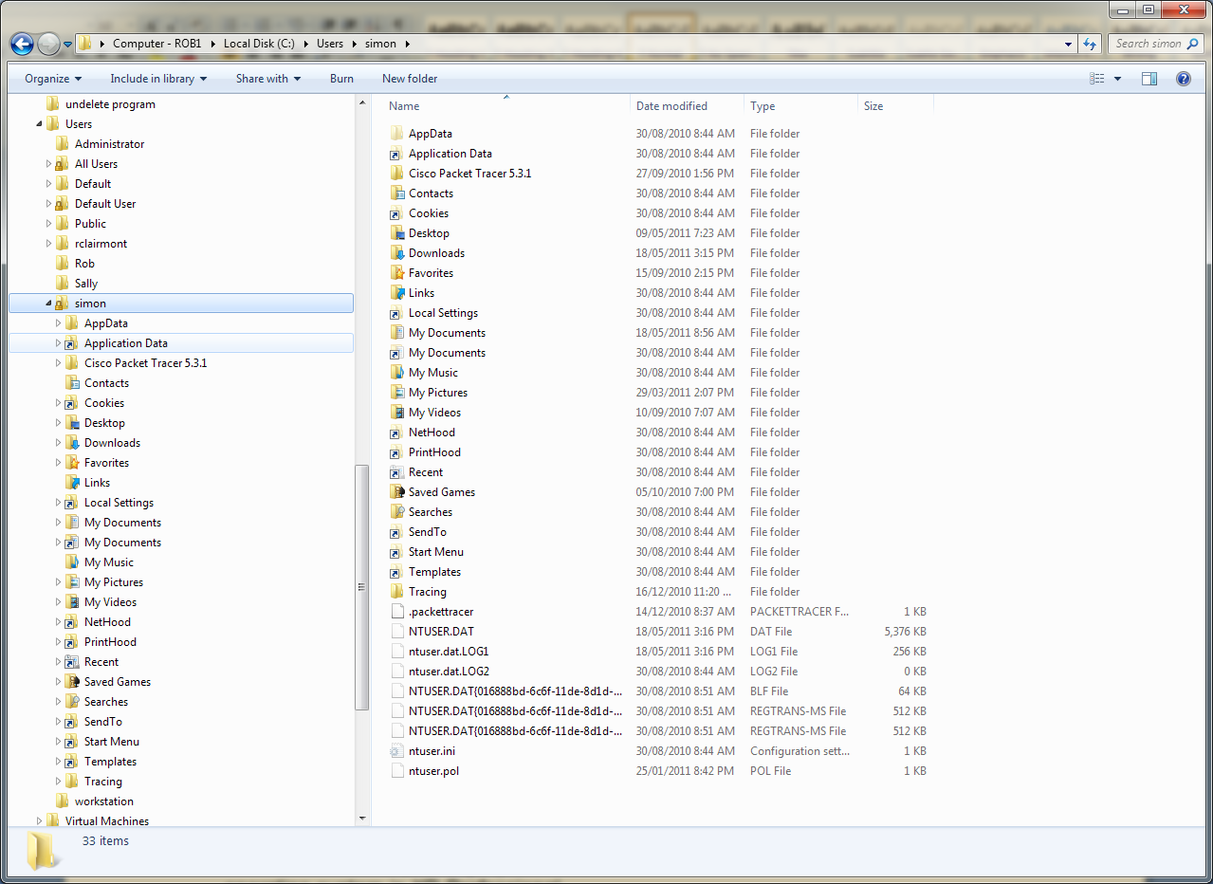

For Windows 7 and later operating systems, the profiles are kept in the **Users** folder in the root of C:. Figure 5 shows the profile for a user called **Simon**.

Fig. 5 User profile in Windows 7

The XP profile and the Windows 7/8/10 profiles, contain a file called **NTUSER.DAT**.

This file contains the user’s unique desktop settings. If the user adds a new icon to his desktop, NTUSER.DAT is updated to record the fact that a new icon has been added.

**Windows 7/8/10 TIP of the day**

Windows 7/8/10 comes with a feature called **Aero.** Aero is a number of

enhancements designed to improve the enjoyment of using Windows.

1. **Aero Shake**

A popular Aero feature is shake title bar to close windows. If you have several

windows open and you want to reduce the clutter, you can click and hold the left

mouse button on the title bar of the window you want to remain open and then

shake the window. All the other windows will close. You can then shake the

window again and all the windows will open again.

2. **Aero Snap**

If you drag a window to the top of the desktop it will expand to maximum size.

When you drag it down again, it reverts to its previous size.

If you have two windows you would like to compare, you can drag one to the right

margin and the other to the left margin and they will resize themselves to become

side by side, each taking up half the desktop.

If you wish to expand a window vertically to fill the desktop without increasing the

width of the window, place the cursor over the top edge of the window until it turn

into a double-headed arrow. Now click and drag the window to the top of the

desktop and the window will automatically expand to the full length of the

desktop. The width remains the same. To return the window to its original size,

simply grab the title bar on the window and drag it away from the top of the

desktop.

3. **Aero Peek**

This feature allows you to see your desktop with X-ray vision. Move the cursor

to the lower right-corner and you open windows become transparent.

See figure 6.

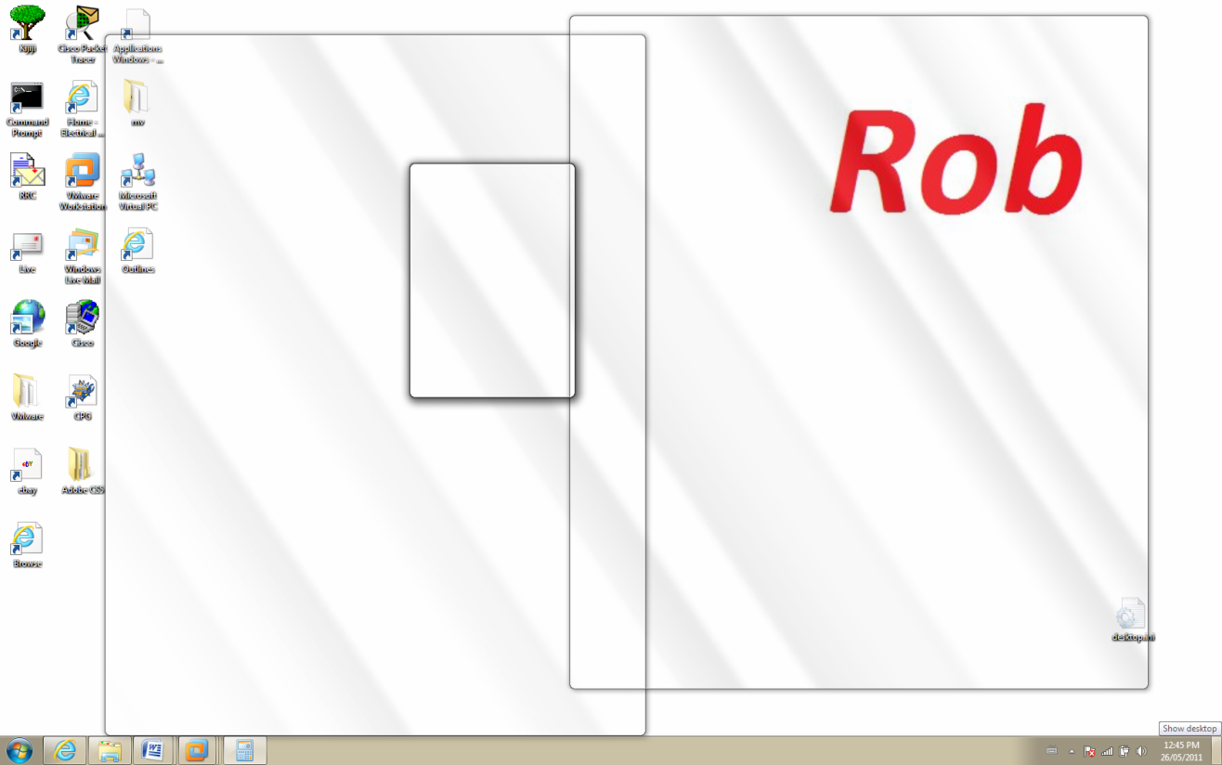

Fig. 6 Aero Peek allows you to see your desktop through the open windows

Windows 8 (A new beast!)

Windows 8 is designed around the same user interface used by mobile devices.

You can use a touch screen to swipe and choose tiles to give you access to

utilities just like a smart phone.

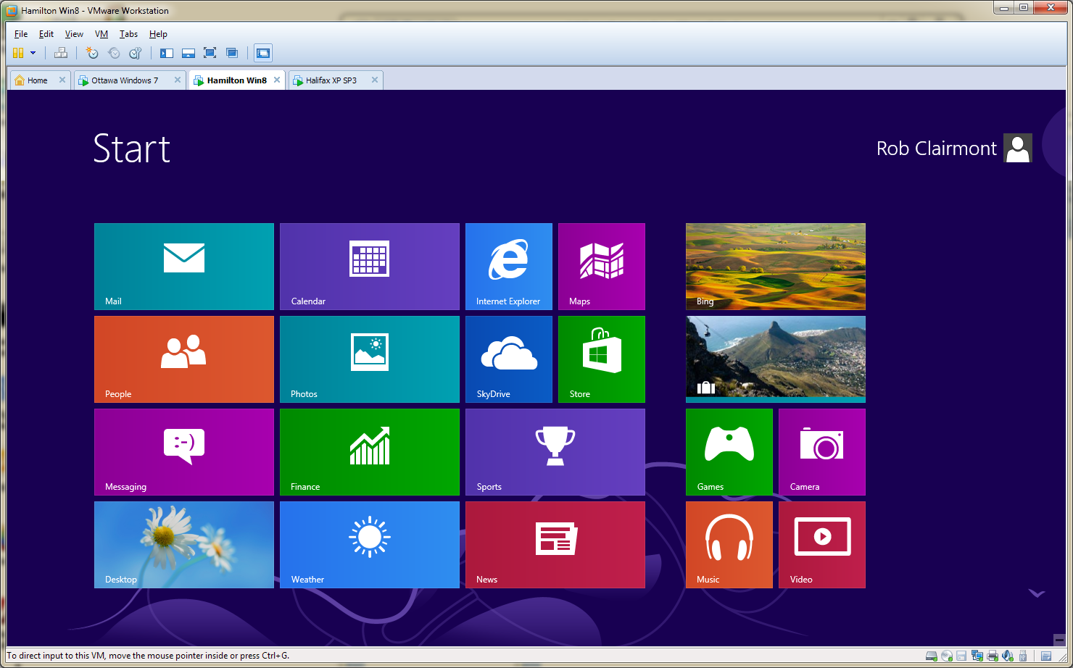

Fig. 7 The Start screen on a Windows 8 machine

One of the most disturbing features of Windows 8 that takes some getting used

to, is the fact that there is no **Start** button. All features accessed by the start

button still exist, it’s just finding them that requires time to learn.

Also, turning off Windows 8 is not so easy to figure out. You must call up the

“charms” menu as shown in figure 8, by placing the cursor in the lower right

corner. When you click on the gear-icon, the window in the lower half of figure

8 appears. The power button is found in the lower right corner.

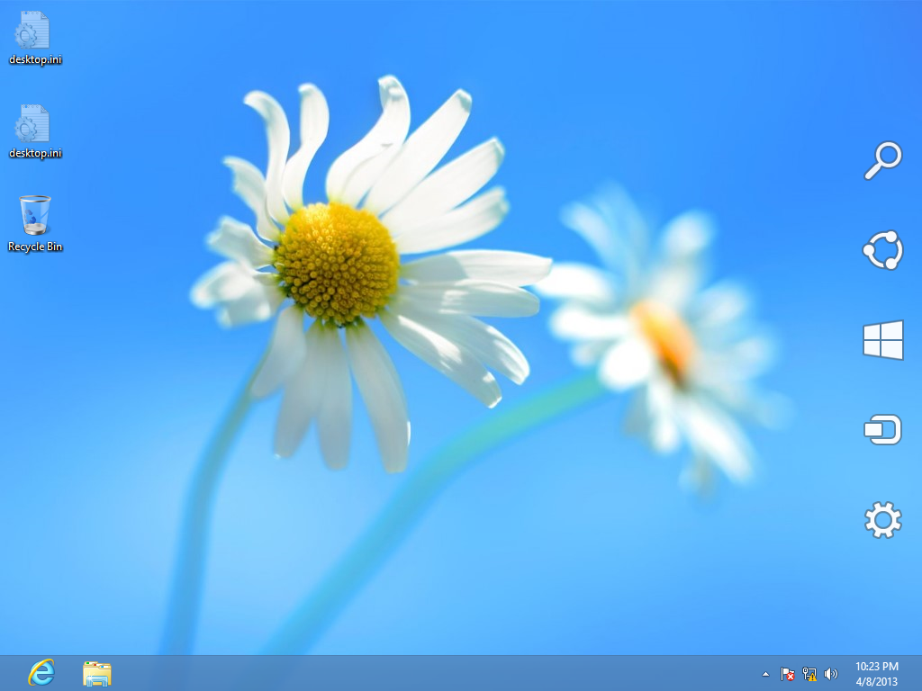

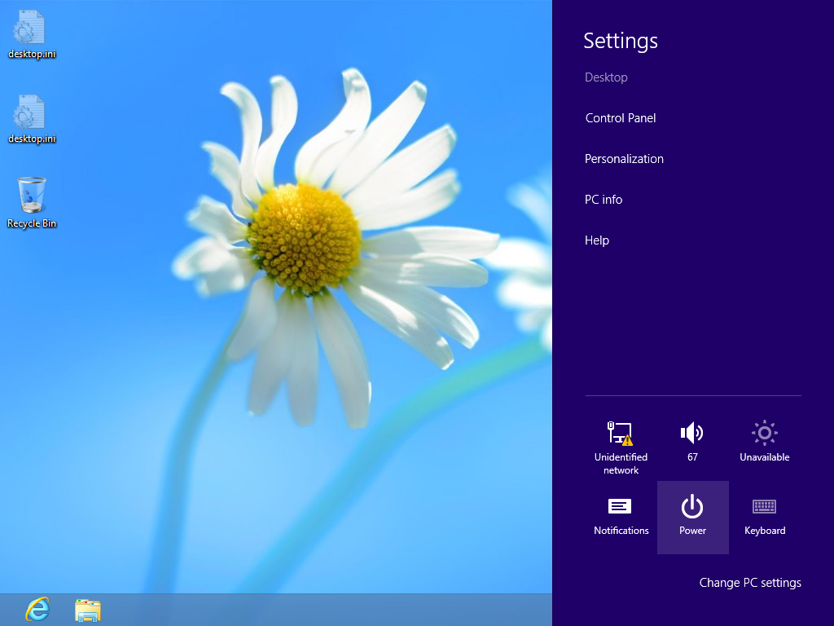

Fig. 8 Turning off a Windows 8 machine

**Navigating Windows 10**

The user interface for Windows 8 was a little disturbing to users so with Windows

8.1 Microsoft nudged closer to the look of Windows 7. Windows 10 incorporates

a more Windows 7-like user interface than even Windows 8.1 used.

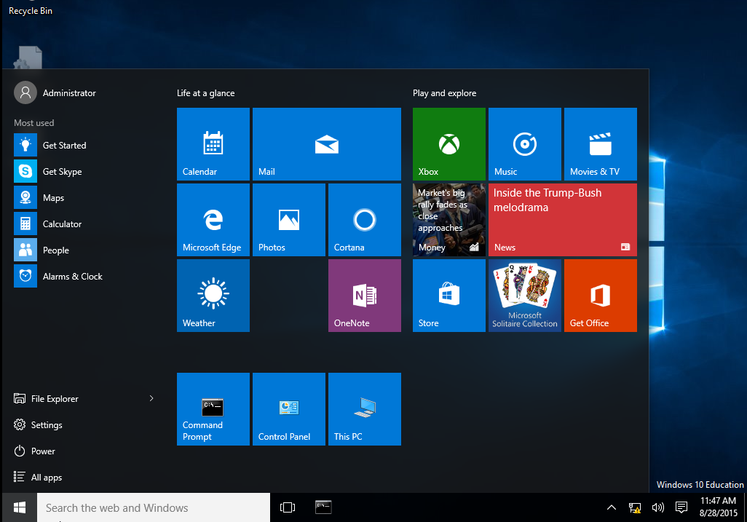

Fig. 9 Windows 10 start screen

You can see in figure 9, there is a start button in the lower left corner. When you

click on it you get the view shown in figure 9. This is a cross between Windows 7

and Windows 8.1.

You can see the **Power** button is easily accessible.